**Formal Verification**

**Question 1**

Indicate if statements are correct.

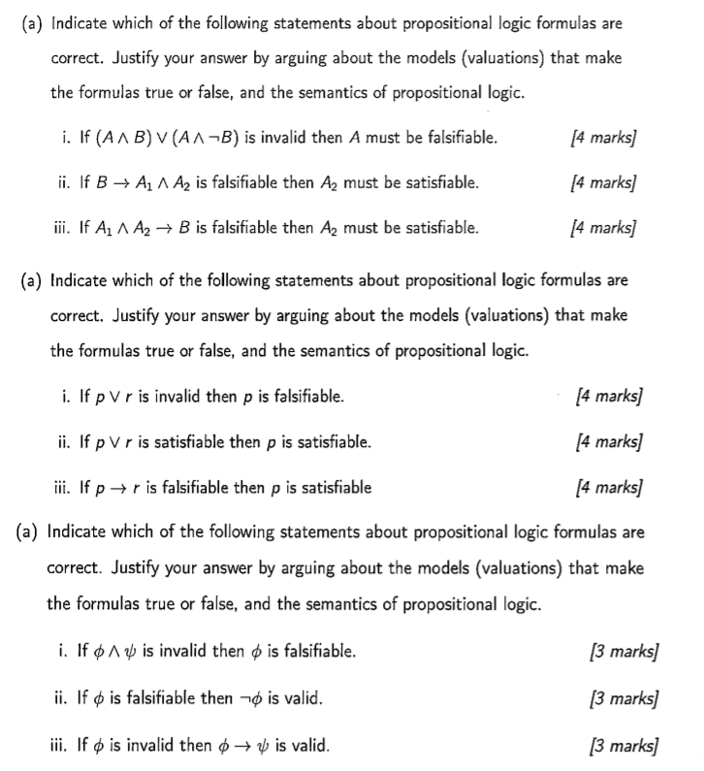

Determine which of the following formulas are equivalent. Can use truth tables and tautologies.

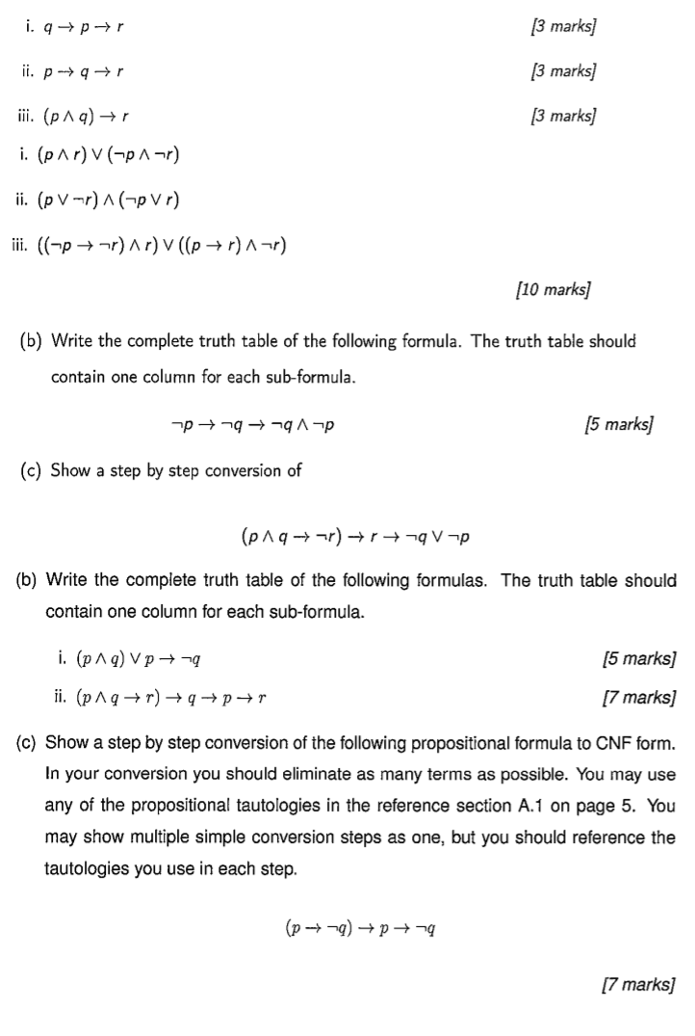

Give classical syntactic proofs for the following sequents.

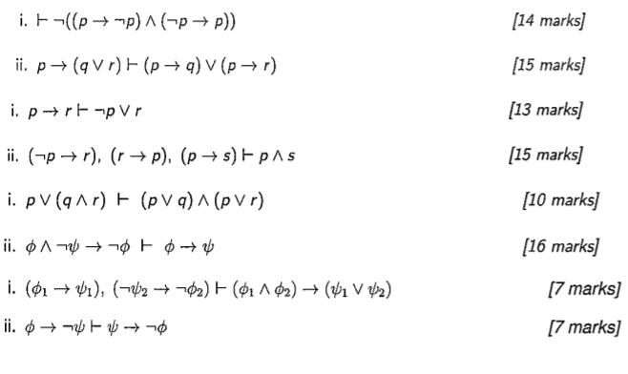

**Question 2**

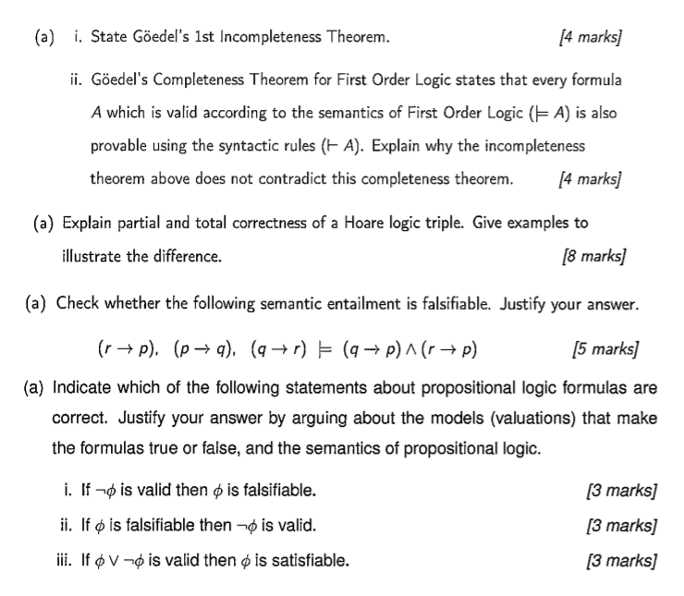

(b)

Translate the following statements into FOL formulas

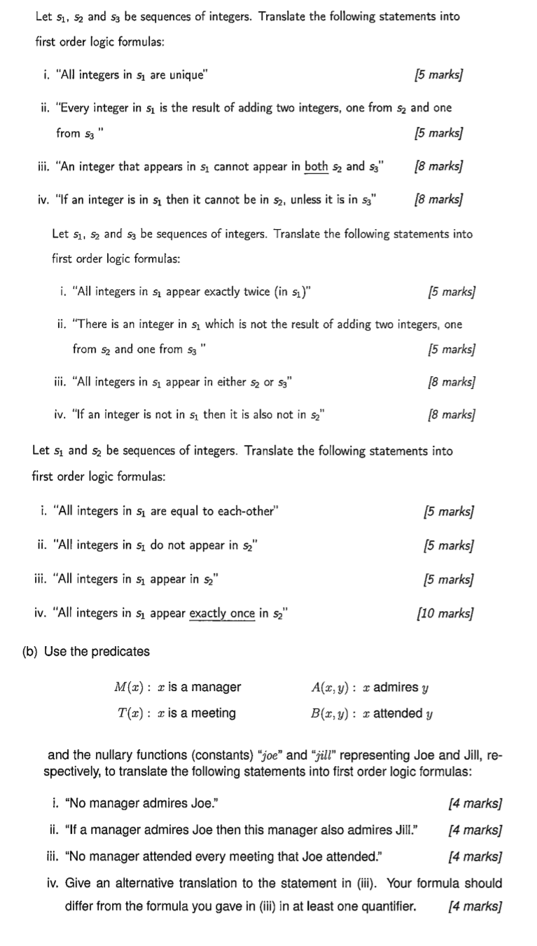

(c)

Give syntactic proofs of the validity of the following sequents.

